S_ALR_87012052 -

Functionality
The report displays, per asset, the retirement documents in the fiscal year. Each document shows the
Retired acquisition and production costs
Retired quantity
Retired proportional depreciation
Earned revenue
Gain/loss
Possible retirement costs
However, the retirement costs have no affect on the gain or loss. Retirement costs are independent of gain or loss in this report, and are displayed for statistical purposes only.

Scenario
This system task is used to display a list of current year asset retirements.

Requirements
None.

Menu Path | SAP menu → Accounting → Financial Accounting → Fixed Assets → Information System → Reports on Asset Accounting → Day-to-Day Activities → International →S_ALR_87012052 - Asset Retirements
Transaction Code | S_ALR_87012052

1. Double Click on S_ALR_87012052 - Asset Retirements

Asset Retirements

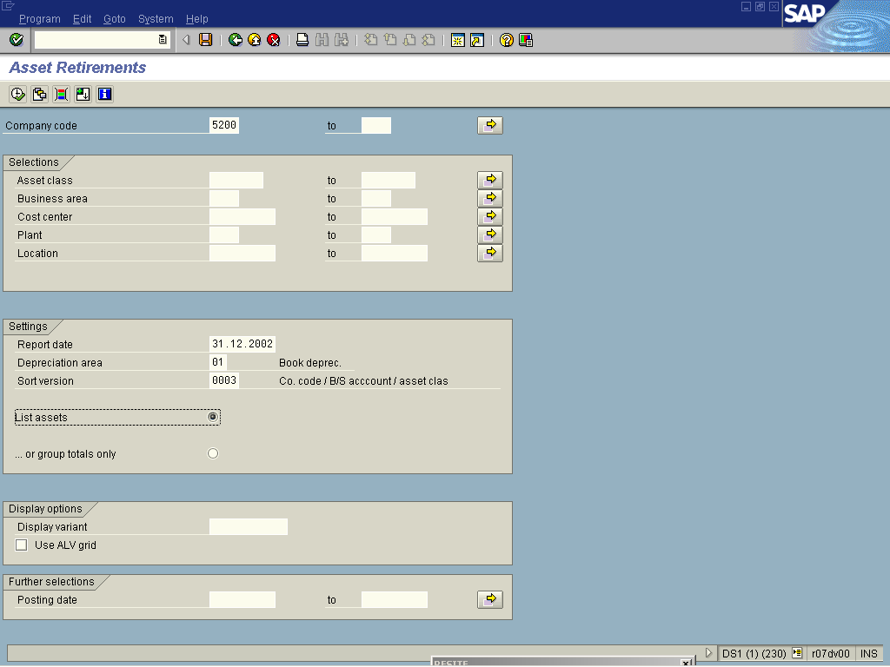
2. Update the following fields:

Field Name | Field Description | Values
Company code | Organizational unit within financial accounting. | Example: 5200
3. Click <radio button> List assets .
4. Click Execute .

Asset Retirements

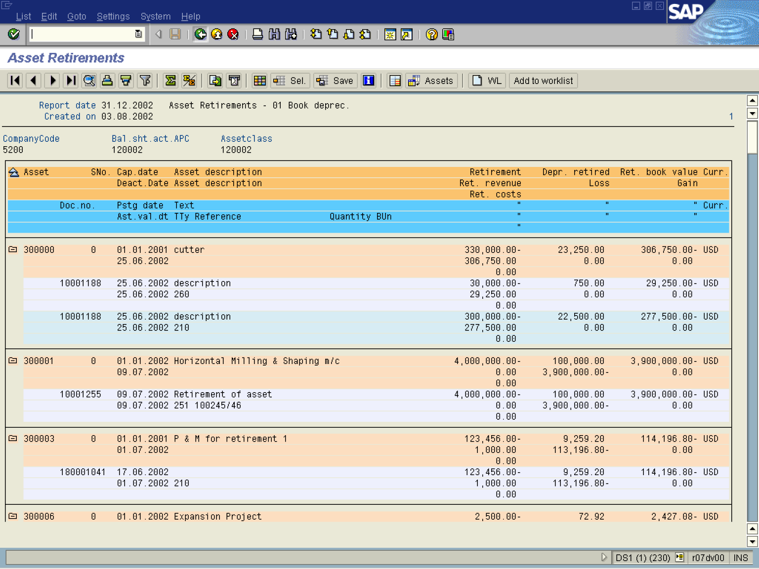

5. The system displays a list of asset retirements for the year.

